

**AC DC EVSE TEST SYSTEM SOLUTION**

# Overview

DC and AC EVSE Testing System Solution, capable of testing interoperability, protocol consistency, metering calibration, etc. This testing platform features fully automatic testing and generating test reports automatically upon completion, thus significantly enhancing on-site testing efficiency. It provides reliable testing grounds for network entry detection and on-site acceptance of charging stations. The schematic diagram of the principle is as follows:

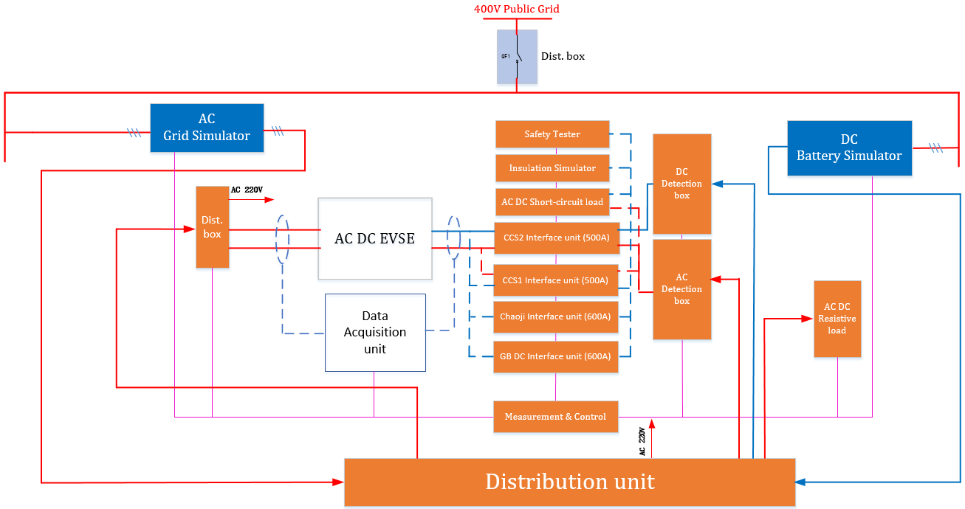

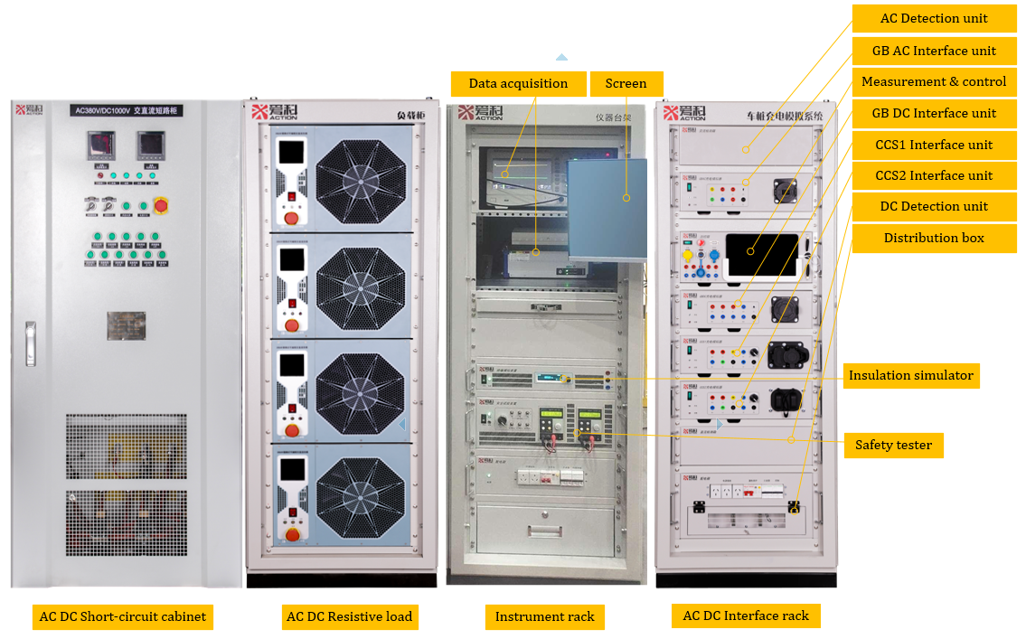

**Dimension:** **800mm×800mm×1800mm； 610mm×800mm×1800mm； 610mm×800mm×1800mm ； 610mm×800mm×1800mm**

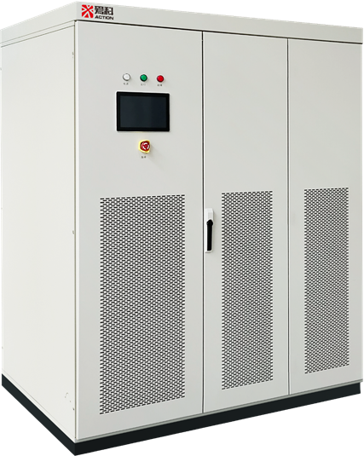

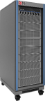

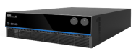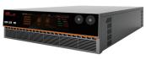

Grid simulator Battery simulator

# Features

* Support for the latest standard test project requirements
* Testing conditions are real, accurately reflecting standard definitions
* Customization of standards can be achieved according to requirements
* Support for custom test item editing
* Support for protection limits of the tested product
* Support for manual and automatic process testing functions
* Self-check function, able to self-check the status of each device during power-on initialization and report to the system
* Data and fault feedback
* Automatically generate PDF or Word reports based on test results
* Able to load test instruments selected by the customer
* Hierarchical operator permission management function

# Test regulation

## 3.1 Regulation followed

|  |  |  |
| --- | --- | --- |
| **No.** | **Regulation** | **Description** |
|  | EN/IEC 61851-24：2014 | Digital communication between a DC EV charging station and an electric vehicle for control of DC charging |
|  | ISO 15118-1-2013 | Road vehicle - Vehicle to grid communication interface  Part 1: General information and use-case definition |
|  | ISO 15118-2-2013 | Road vehicle - Vehicle to grid communication interface  Part 2: Network and application protocol requirements |
|  | ISO 15118-3-2013 | Road vehicle - Vehicle to grid communication interface  Part 3: Physical and data link layer requirements |
|  | DIN 70121-2014 | Electromobility –Digital communication between a d.c. EV charging station and an electric vehicle for control of d.c. charging in the Combined Charging System |
|  | IEC 62196-3-2022 | Plugs, socket-outlets, vehicle connectors and vehicle inlets – Conductive charging of electric vehicle |
|  | NB/T 33001-2018 | Specification for electric vehicle off-board conductive charger |
|  | NB/T 33002-2018 | Specification for electric vehicle AC charging spot |
|  | GB/T 18487.1-2023 | Electric Vehicle Conductive Charging System  Part 1: General Requirement |
|  | GB/T 27930-2023 | Digital Communication Protocols Between Off-board Conductive Charger and Electric Vehicle |
|  | GB/T 20234.1-2023 | Connection set for conductive charging of electric vehicle  Part 1：General requirements |
|  | GB/T 20234.2-2023 | Connection set for conductive charging of electric vehicle  Part 2：AC Charging coupler |
|  | GB/T 20234.3-2023 | Connection set for conductive charging of electric vehicle  Part 3：DC Charging coupler |

## 3.2 Test items followed

|  |  |  |  |  |
| --- | --- | --- | --- | --- |
| Regulation | IEC61851-23 | ISO15118-4-2018 | ISO15118-5-2018 | DIN70122-2018 |
| Total | 49 | 292 | 102 | 204 |
| Actionpower | 49 | 248 | 57 | 171 |

## 3.3 Support for future regulation upgrades

|  |  |  |
| --- | --- | --- |
| **No.** | **Regulation** | **Description** |
| 1 | IEC 61851-1: 2019 | Electric vehicle conductive charging system-Part 1 General requirements |
| 2 | IEC 61851-24: 2014 | Electric vehicle conductive charging system Part 24: Digital communication between a d.c. EV charging station and an electric vehicle for control of d.c. charging |
| 3 | UL2022: 2018 | Electric Vehicle (EV) Charging System Equipment |
| 4 | UL2594: 2016 | STANDARD FOR SAFETY Electric Vehicle Supply Equipment |

# Software

## 4.1 Overview

Action 2020 Industry Solution Integrated development environment, applicable to various industries: manufacturer R&D testing, system integration, production line automated testing, testing agency verification testing, etc.

Providing virtual control panels for equipment, visually displaying the operation status of each device.

## 4.2 Feature

|  |  |
| --- | --- |
| Device management | * Support for ATE integrated equipment registration * Ability to add, delete, and publish various types of devices * Equipped with one-click device diagnosis function * Ability to set source-load type of combinations * Support for hardware configuration import and export * Ability to perform system hardware replication |
| Test case services | * Drag-and-drop for complex test item editing * Compilation checks for test case * Highlighting of compilation and simulation errors * Support for importing and exporting test items via Excel |
| Test program services | * Integration of standards, product testing, and inspections through test case combination * Support for compliance checks * Highlighting of compilation and simulation errors * Support for importing and exporting test items via Excel |
| Solution services | * One-click to start testing * Highlighted execution items * Quick display of PASS/FAIL results * Automatic adaptation of EUT parameters |
| Test report service | * Customization of report style and content * Support for importing Word templates * Automatically adapting template to fill in test data and generate reports |
| Statistical Analysis Services | * Test data analysis and statistics * Built-in selection of statistical rules * Daily, monthly, yearly reports * Reserved MES push interface |
| Multi-user login | To meet the software permission management requirements of customers, different interface levels are set up for testing, R&D, production line, and other positions, including operator, programmer, and administrator levels, providing more flexible operation and easier management. |
| User-friendly operation | * User-friendly operating interface, making operations easy and the interface friendly. During testing, the status of running steps is clearly visible, with real-time display of current and voltage curves. The testing process data is very intuitive, and specific values can be viewed through the data box. * Test waveform can be exported as image files, making it convenient for writing test reports and other purposes. * It supports multi-channel display, requiring only one workstation to control the operation of multiple devices, allowing real-time monitoring of data from each device. |
| Multiple editing | Three editing interfaces are provided, namely CAN Data, MODBUS Data, and Step Management.   * For CAN Data, it supports direct import of dbc files into CAN data files, and allows for content editing. Different CAN data files can be configured for different products. * For MODBUS Data, it supports functional expansion. By editing or importing MODBUS data protocols, data from environmental chambers, salt spray chambers, and other equipment can be fed back to the TAS platform for real-time monitoring and control. * For Step Management, it supports up to 9999 steps, meeting the maximum requirements for complex testing processes. The diverse types of steps also provide users with different testing methods. |
| Efficient system management | * File management, testing data path interface support querying test reports and testing data from the local database, facilitating data recording for production, maintenance, and debugging, and making it convenient for problem tracing. Additionally, it can be integrated with the factory MES system to meet customers' needs for data query and report printing anytime and anywhere. * User management can be assigned different levels of access to meet the usage requirements of various positions such as production, process, and research and development. * System settings can set system protection values, record interval times, etc., to provide a safe and convenient user experience. |
| Customizing Reports | * At the end of system test, the test items and results will be displayed, making it convenient for users to view the test results at the end of each test without having to check local record files or records stored in the MES system. * A report will be automatically generated at the end of each test, and users can customize the format of the report. |

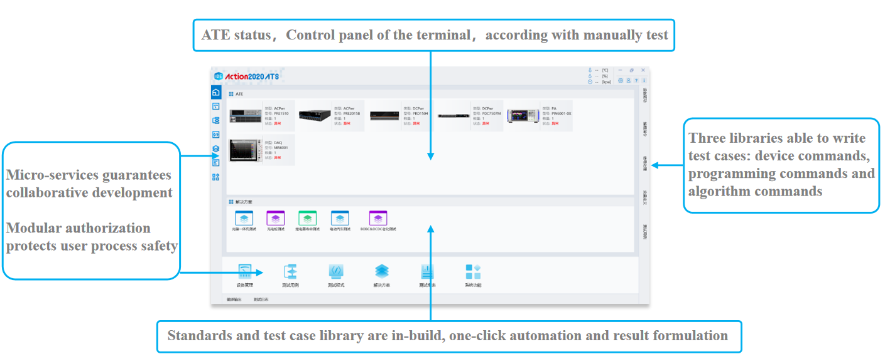

# Specification

## 5.1 AC DC Interface rack

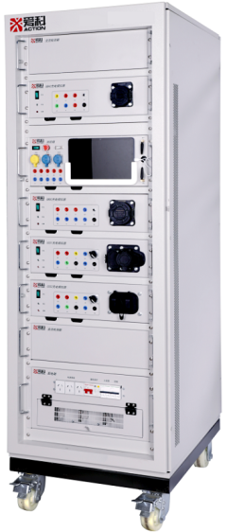



**AC Detection unit**



**GB AC Interface unit**





**Measure & Control unit**



**GB DC Interface unit**



**CCS1 Interface unit**



**CCS2 Interface unit**

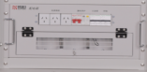

**DC Detection unit**

**Distribution box**

**(610mm*800mm*1800mm)**

AC DC Interface Rack

|  |  |  |
| --- | --- | --- |
| **Items** | **Feature** | **Parameter** |
| AC Detection unit | Built-in high precision AC hall sensor with current range 0 ~ 90A, and high voltage AC relay with voltage range 0 ~ 400Vac. The detection unit connected with AC load and will control its on/off, while the output current from AC EVSE has been sampled. | / |
| GB AC Interface unit | 1. One of the 63A standard charging jacks is included, and meets GB/T 20234.3-2015 regulation. 2. ABC 3-phase, N, PE, CP and CC switches on circuit loops are included, able to simulate related fault states. 3. AC guide circuit is included, R2, R3 are settable to simulate the equivalent resistance. 4. Built-in 3-phase current hall sensor with 100A range, able to sample the high precision current. 5. Emergency button is included. 6. 2 of RS485 and 1 of LAN ensured host PC communication. 7. 3-phase load interface with max 90A current capacity 8. Input 220V±5%, 50Hz | 1. AC input: AC 250V/480V 2. Current input: AC 0 ~ 90A 3. R2, R3: 100 ~ 10000 continuously settable, step 0.1, accuracy 0.1% F.S. 4. Current sapling accuracy: 0.1% |
| Measurement & Control | 1. 4U 19’’ standard module design 2. With wave-recording function, 16 channels and 16 bit high precision 3. Emergency function 4. EVSE interface circuit, waveform sampling, PLC collection, CAN collection, EVSE fault simulation are all integrated into the unit. 5. Remote control for control and configuration. 6. 1 RS485 in front for short-circuit load control, 1 RS232 and 1 LAN on back. 7. Input AC 220V±5%, 50Hz | / |
| GB DC Interface unit | 1. One of the 1000V/600A jacks are included. 2. Charging controller is included, able to analyze CAN message, EVSE fault simulation etc. 3. Charge interface circuit is included, able to do CAN collection, EVSE fault and voltage simulation. 4. Able to expand with DC load 5. Emergency button 6. BMS simulation circuit included, able do analyze CAN message and BMS fault simulation 7. Vehicle control circuit included, R3 and R5 settable 8. High precision metering and charging pile metering included | 1. Rated voltage: 1000V 2. Rated current: 600A 3. Voltage input: 0 ~ 1000V 4. Current input: 0 ~ 600A 5. AC 220V, 50Hz 6. R2: 100 ~ 10000 continuously settable, step 0.1, accuracy 0.1% F.S. 7. Metering: Meets JJG 1149 |
| CCS1 Interface unit | 1. EVSE interface circuit simulation, waveform sampling, PLC collection, battery, charging controller are integrated in the unit. 2. One of the SEA J1772 charging jack, with 1000V voltage and max 600A current. AC voltage 240V, max current 80A(type 1). It is easy for integrated test, and meet DIN70121 charging regulation. (Note: The charging plug will need liquid cooling while the DC current up to 200A) 3. Built-in charging controller, able to do EVSE PLC analysis and EVSE fault simulation etc. 4. Built-in CP, CC amplitude detection, CP duty factor, frequency detection etc. 5. Measurement and calibration terminals are reserved on the panel. | DC Parameter:   1. Rated voltage/current: 1000V/500A 2. Input voltage/current: 0 ~ 1000V/0 ~600A 3. Working voltage: AC 220V 50Hz   AC parameter:   1. Input: AC 240V/0 ~ 80A 2. Current sample accuracy: 0.1% 3. Communication: LAN 4. Working voltage: AC 220V±5%, 50Hz |
| CCS2 Interface unit | 1. EVSE interface circuit simulation, waveform sampling, PLC collection, battery, charging controller are integrated in the unit. 2. One of the IEC 62196 charging jack, with 1000V voltage and max 600A current. AC voltage 480V, max current 63A(type 2). It is easy for integrated test, and meet ISO15118-1, ISO15118-2 and ISO15118-3 charging regulation. (Note: The charging plug will need liquid cooling while the DC current up to 200A) 3. Built-in charging controller, able to do EVSE PLC analysis and EVSE fault simulation etc. 4. Built-in CP, CC amplitude detection, CP duty factor, frequency detection etc. 5. Measurement and calibration terminals are reserved on the panel. | DC Parameter   1. Rated voltage/current: 1000V/500A 2. Input voltage/current: 0 ~ 1000V/0 ~600A 3. Working voltage: AC 220V 50Hz   AC parameter   1. Input: AC 480V/0 ~ 63A 2. Current sample accuracy: 0.1% 3. Communication: LAN   Working voltage: AC 220V±5%, 50Hz |
| DC Detection unit | Built-in high precision DC hall sensor with current range 0 ~ 600A, and high voltage AC relay with voltage range 0 ~ 1500Vdc. The detection unit connected with DC load and will control its on/off, while the output current from DC EVSE has been sampled. | / |
| Distribution box | 1. Able to do customization according to the power requirement 2. AC detection range: 0 ~ 1000A 3. Fault simulation: EVSE PE disconnect 4. Protection: All terminal should have leakage protection to ensure personnel safety. 5. Controllable: 1-phase 1kVA, isolated power supply for instruments, control and sampling. 6. The front panel is equipped with 3 output interfaces, each with a minimum of 3A (reserved for customers). 7. The back panel is equipped with 3 output interfaces, each with a minimum of 3A, capable of meeting the requirements of testing instruments.   Port on the panel   1. Port for public grid and power supply 2. High precision current sensor 3. Distribution switch | 1. AC input/output voltage: 0 ~ 300V 2. AC input/output current: 1000A 3. Voltage sampling channel: AC 3ch 4. Current sampling channel: AC 3ch 5. Current sampling accuracy: ≤0.1% 6. Others: reserve the position of the load expansion port. |

## 5.2 Instrument Rack

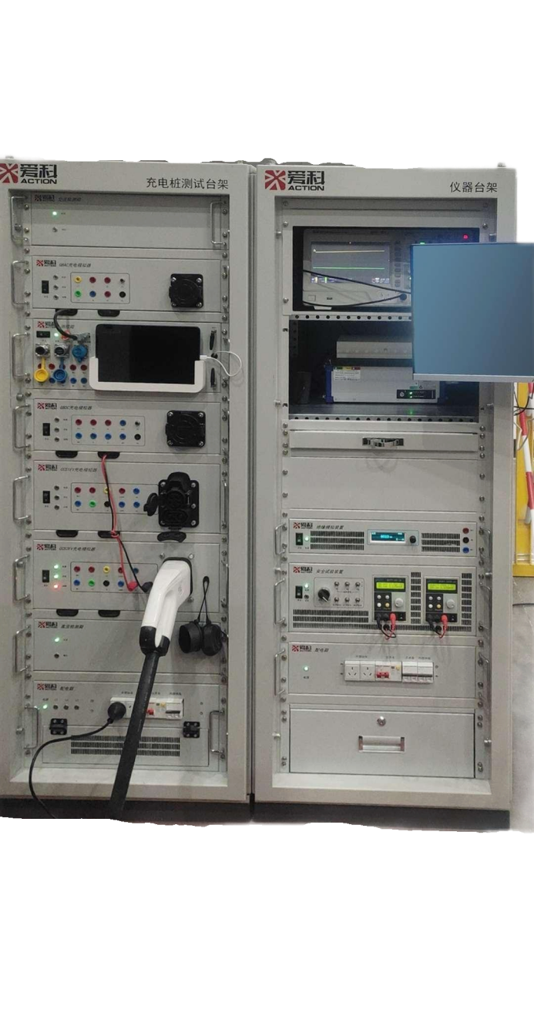

**Screen**

**Instrument**

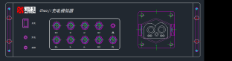



**Chaoji Interface front(CAD)**

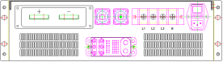

**Insulation simulator**

**Chaoji Interface back(CAD)**

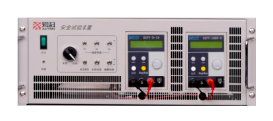

**Safety tester**

**610mm×800mm×1800mm**

|  |  |  |
| --- | --- | --- |
| **Items** | **Feature** | **Parameter** |
| Insulation simulator | 1. Able to simulate functions of both symmetrical insulation and asymmetrical insulation for the EVSE. 2. Module design, 2U size 3. Flexible control mode, with both remote PC and local manual 4. Withstand voltage range: 0 ~ 1000V(include insulation state) 5. Resistance adjustable with range 10kΩ~810kΩ, step 1kΩ, error≤±2% 6. Short-time load tolerance with 10 times power, 5s. | 1. Input voltage range: 0 ~ 1000V 2. Rated current: 0.1A 3. Cooling mode: Fan 4. Temperature: -20℃～+40℃ 5. Communication: RS485, Modbus RTU |
| Safety tester | 1. Able to simulate the voltage of battery pack and adjustable, minimum step 0.1V 2. Voltage simulation range 0 ~ 1000V, accuracy 0.5% 3. Equipped with reverse output function, which can be used to measure the reverse connection protection function of EVSE, meeting the testing requirements of the battery reverse connection test items specified in NB/T33008.1-2013 and Q/GDW 1591-2014. 4. Equipped with test load, able to test the loading capacity of the 12V auxiliary power supply of EVSE, with three options: 9A, 2A and 4A, those options can be customized expansion. 5. Able to do auxiliary power supply over voltage, over current, short circuit test 6. Input AC 220V±5%, 50Hz | 1. Input from EVSE: DC 200V ~ 1000V 2. Battery reverse voltage simulation: 0 ~ 1000V, PX. 0.1V 3. Battery voltage simulation: 0 ~ 1000V/1A, PX. 0.1V 4. Withstand voltage: 1000V above 5. Cooling mode: Fan 6. Communication: RS485, Modbus RTU 7. Temperature: -20℃～+50℃ |
| Instruments | Available for setting the instruments like power analyzer and scope, etc. | \ |
| Screen | Mobility | \ |
| Chaoji interface unit (available) | 1. Voltage level up to DC 1500V, max current up to 600A 2. With 4mm standard measurement port, for collecting of signal from each channel and signals on both sides of switch. 3. Chaoji jack on the device interface 4. Remote control for parameter configuration, etc. 5. BMS simulator and CAN protocol with decode/analysis function 6. Input AC 220V±5%, 50Hz | 1. Rated voltage: DC 1500V (Jack withstand 1000V) 2. Rated current: 600A 3. Input voltage range: 0 ~ 1500V 4. Input current range: 0 ~ 600A |

## 5.3 AC DC Resistive Load

The programmable AC DC load cabinet consists of individual 30kW load modules, with every four modules forming one vertical cabinet. A total of 120kW programmable AC/DC load requires one 19-inch standard cabinet. The performance parameters of each module are identical, and users can configure them according to their own needs. The schematic diagram of the programmable AC/DC load is as follows:

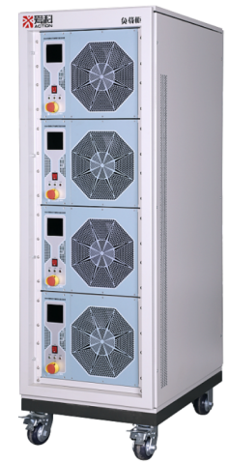

**600mm×800mm×1800mm**

|  |  |
| --- | --- |
| **Feature** | **Parameter(single module)** |
| * Control mode: Remote control with host PC, RS485 communication * Display mode: Voltage, current, power and duration, etc. are available * Working mode: CC, CP and CR mode * Load control: Multiple current switches on the load panel, combination of different switches meet the requirement of current, power test * Protection mode: Automatically trigger an alarm and cut off the load while the internal temperature, current, or voltage exceeds or falls below the specified limits | * Input voltage: DC 200V ~ 1000V AC 220V * Discharge power: 30kW@300-1000Vdc; 15kW@220Vac * Current&power: Imax: 30A@1000V, [60A@500V, 100A@300V, 68.42A@220Vac](mailto:60A@500V、100A@300V、68.42A@220Vac) Pmax: 30kW@300-1000VDC, 15kW@220Vac * Current step: [0.022A@220Vac; 0.02A@200Vdc; 0.05A@500Vdc](mailto:0.022A@220Vac;0.02A@200Vdc;0.05A@500Vdc); 0.075A@750Vdc; 0.1A@1000Vdc * Voltage accuracy/resolution: ±0.5%F.S./0.1V * Current accuracy/resolution: ±0.5%F.S./0.1A * Parallel: Master/slave mode settable on panel, RS485 connecting to master device and CAN connection between master and slave. * Communication: The load regulation is controlled by the host, synchronized through CAN communication, with a communication rate of 1Mbps. * Input impedance: Positive and negative input under 500Vdc, 10 megohm R * Discharge mode: CC, CV, CR * Cooling mode: Forced fan * Protection level: IP20 * Input: AC220V±10%, 50Hz±1Hz * HMI: LCD * Size: 8U 19’’ |

## 5.4 AC DC Short-circuit cabinet

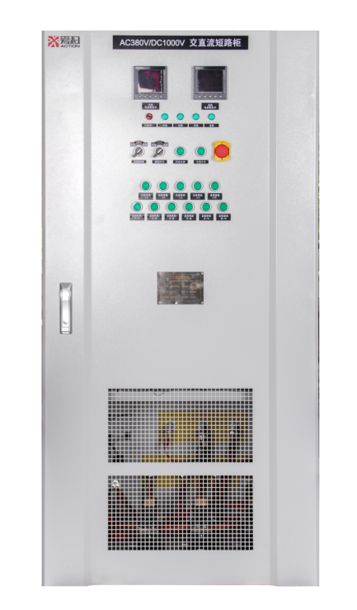

**800mm×800mm×1600mm**

|  |  |
| --- | --- |
| **Feature** | **Parameter** |
| * Short-circuit simulation test: Able to load any power within the rated value * AC current limit mode: A-B current limiting resistor 1.8R, current 211A; A-N current limiting resistor 0.9R, current 245A; 0.9R reserved for phase C * Short mode: A-B, A-N short current is designed with 500A * DC current limit mode: Series LR * DC short mode configuration 1: Series LR * DC short mode configuration 2: Series LR * DC short mode configuration 3: Series LR * PE loop, grounding resistance 1kΩ: DC positive grounding/DC negative grounding/AC L1 grounding, and corresponding control mode either remote or local. * Switches/button: power switch, fan switch, local/remote switch, mode switch, AC/DC short-circuit switch, AC/DC current limit switch * Protection function   Fan cooling: The cooling fan must be started first before doing current limiting or short-circuit tests.  Emergency control: In case of an emergency during operation, pressing the red "Emergency Stop" switch immediately will remove all loads from the device. Fault and emergency stop indicator lights will illuminate, accompanied by an audible alarm. In this state, the load function is locked, with only the fan continuing to operate.  OT protection: When the internal temperature of the device exceeds the preset warning threshold, some protection functions come with switches. The protection switch defaults to the "downward" state, allowing normal alarms. If there is a false alarm from the protection function or if certain protection functions need to be temporarily disabled, the corresponding protection switch can be toggled upwards to the "closed" position. In this state, alarms will no longer occur under the corresponding conditions.  Automatic protection: The machine is equipped with automatic protection function. When it occurs, fault and alarm indicator lights will illuminate, accompanied by an audible alarm. All loads will be automatically removed. The loading function is locked in protection mode. Please identify and troubleshoot the issue, and resume testing only after the alarm is cleared.   * Indicator: Including power on indicator, fan indicator , local/remote control indicator, current limiting/short circuit mode indicator , AC/DC short circuit indicator, AC/DC current limiting indicator. Panel installation, illuminated in case of malfunction (red), and normal operation (green). Additionally, the status light can be remotely controlled. | * Rated voltage: DC 1000V/1000A; 3-phase AC 380v/245aA * Max load current: DC 1000A, AC 500A * Power factor: 1 * Load accuracy: ≤±2%(current-limiting resistance) * Input: 1-phase AC 220V/50Hz, 1kW * Wiring mode: Load power input with copper, control power input with 3-pin socket * Insulation level: F * Working mode:   Under AC: Work for 12 seconds (calculated from voltage acquisition to 200V), then stop after 12 seconds. Ready to start after a 1-minute pause.  Under DC: Work for 5 seconds (calculated from voltage acquisition to 100V), then stop after 5 seconds. Ready to start after a 1-minute pause.  There is no time limit for the AC/DC to PE contactor.  If the host PC issues a command to disconnect the contactor during its closing period, the contactor disconnects normally. After disconnection, restart is ready after a 1-minute pause.   * Cooling mode: Forced fan * Transportation: Lifting * Case color: Grey(RAL7035) * Temperature: -20℃～+50℃ * Humidity: ≤95% * Altitude: ≤2500m |